
V
O
L
U
M
E

5
7
,

N
O
.

6
WEEK OF FEBRUARY 13TH, 2023
The Church of the Good Shepherd
The Word
of the
Church of the Good Shepherd

United Methodist Church

United Methodist Church
400 W. Duarte Road, Arcadia, CA 91007 || www.cgsum.org || 626-447-2181 Join us for Sunday Worship at 10:00 a.m. IN-PERSON in our Sanctuary Broadcast Live at 10:00 a.m. to Facebook/CGSUM and to CGSUM.ORG

Sunday, February 19th, 2023, Transfiguration Sunday
Please enter the Sanctuary worship through the double doors off the parking lot. Name tags and check-in are not needed. Attendance pads are in the pews. Masks are no longer required but are encouraged for those who have high risk factors.
Prelude: "Day by Day" arr. Porter
Introit: "Lead Kindly, Light" by J.B. Dykes;
Scripture Lessons: Psalm 99 and Matthew 17:1-9
Anthem: "Christ Whose Glory Fills the Skies" by Gilbert Martin; Kirk Averitt, Director, Chancel Choir Director
Sermon: "To Live Inside Out: Jesus's Identity Revealed", Rev. Eva Thai-Erwin Preaching
Children's Choir Anthem: "God is Calling Us (incorporating "Kum Ba Ya")" by Sleeth Diane Lucas, Children's Choir Director and Janice Clark, Accompanist
Postlude: "Dialogue" by Adriano Banchieri, Stephen Cook, Director of Music

The Feb. 12th Altar Flowers were given by Elaine Drew in Memory of Molly, a longtime travel friend.
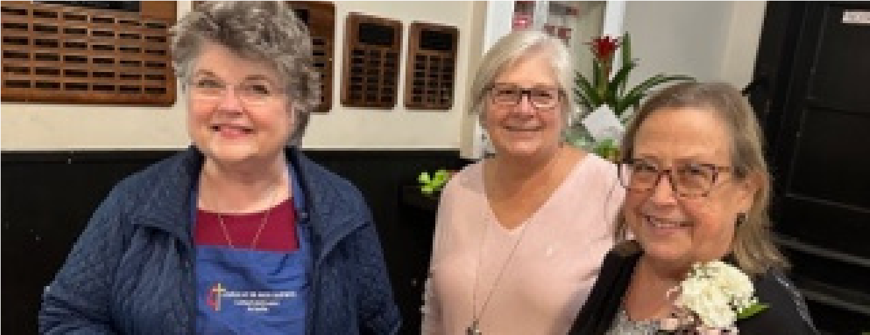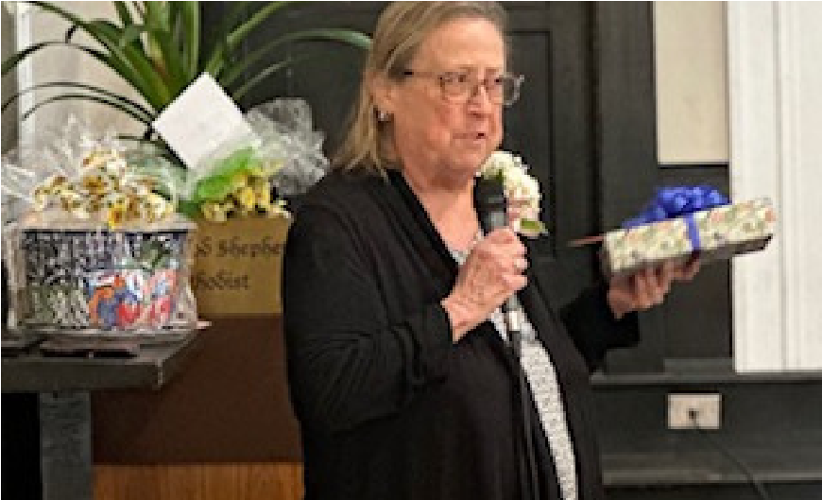
On Feb. 5th, we were able to celebrate the retirement of Linda Doran and 30 years of faithful service!

All articles, photos, and announcements are due by 3:00 p.m. Friday for the following week's newsletter and should be emailed to cgsarcadianewsletter@gmail.com.

Beginning February 22, the Women's Book Group will read and discuss The Prodigal Prophet: Jonah and the Mystery of God's Mercy. Join us on
Wednesdays at noon! Contact Leslie Kenan or the Church for more details.

CYBERSECURITY WEBINAR OFFERED ONLINE FEB. 21st (11am) Please share with family and friends and RSVP by Feb. 17th! To continue the wonderful tradition that began many years ago with John and June Fee, the Finance and other Committees will offer special educational Forums through out the year. For February, the Finacnce Committee is offering a Free
Cybersecurity Presentation by Morgan Stanley on February 21st, ONLINE at 11:00am. Please RSVP to Natalie Poole (napoole@earthlink.net) and a secure link that will allow you to attend online will be emailed to you.


The Importance of Self-Check: A Virtual Educational Lecture
Wednesday, February 22nd, 2023 at 12:30 p.m.
February is National Self-Check Month, an opportunity for you to become more proactive about your health -- and increase your odds of avoiding chronic disease. During this special event, Derek Cheung, MD, will provide information about early disease detection techniques.
These educational lectures are held via Zoom, and a call-in option is also available. The lecture will last about an hour and will include time for questions. Participation is free. All participants must register in advance either online (huntingtonhealth.org) or by calling the membership line at (626) 397-3147.


Best Wishes to Jeff Doran, Church Custodian and Sunday Worship Tech
Jeff Doran will be leaving his church position to spend time with his wife, newborn daughter, and children in the Philippines. Let us wish him congratulations on his daughter's baptism that will take place when he is there, and also keep him and his family in our prayers as they will be working on future plans. SPRC hopes to host an Appreciation event for him in the Summer when he is back in Arcadia and before he needs to return to the Philippines.


February 22nd in the Chapel, stop by anytime between 8:00-9:00a.m. & 5:30-7:00pm for Prayers and the receiving of Ashes
Each year, Ash Wednesday marks the beginning of Lent and is always 46 days before Easter Sunday. Lent is a 40-day season (not counting Sundays) marked by repentance, fasting, reflection, and ultimately celebration. The 40-day period represents Christ’s time in the wilderness, where he fasted, prayed, and reflected. Lent asks believers to set aside a time each year for similar prayer and reflection to focus on Christ’s life, ministry, sacrifice, and resurrection.

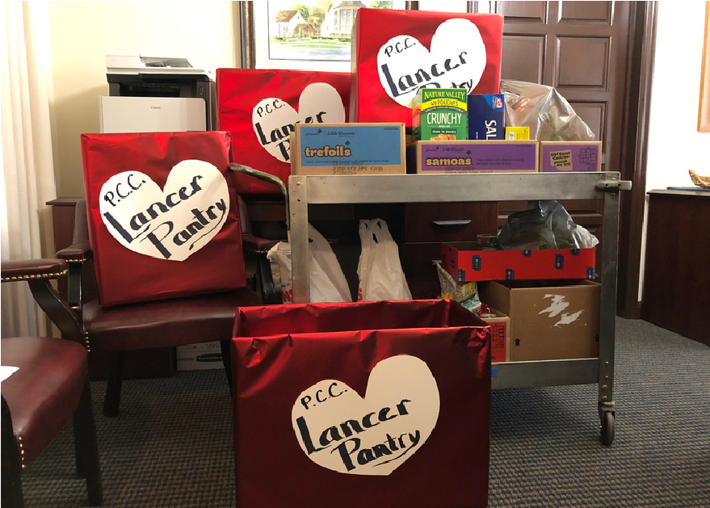
Sarah Circle & United Women in Faith
Thank All Who Donated to the Have a Heart Sunday Food Drive!

Over 200 food items were donated (including items from Girl Scout Troop 7901). These items will be delivered this Friday to the Lancer Food Pantry at Pasadena City College that helps students in need.

Avenue of the Churches Walk - April 15th, 2023
(9am-12pm)
Join us for a walking fundraiser for Family Promise!
Registration costs $25 per person and includes a bib, food, water, and donated items from local businesses that will be raffled off at the end of the event.

SAVE THE DATE: INNOVATION & COMMUNICATIONS
Sunday, Feb. 26th after Worship
Join us in the Lounge for a discussion on ideas, events, communication needs, and more as we move the church forward into the future!
Stay tuned for more details to come.
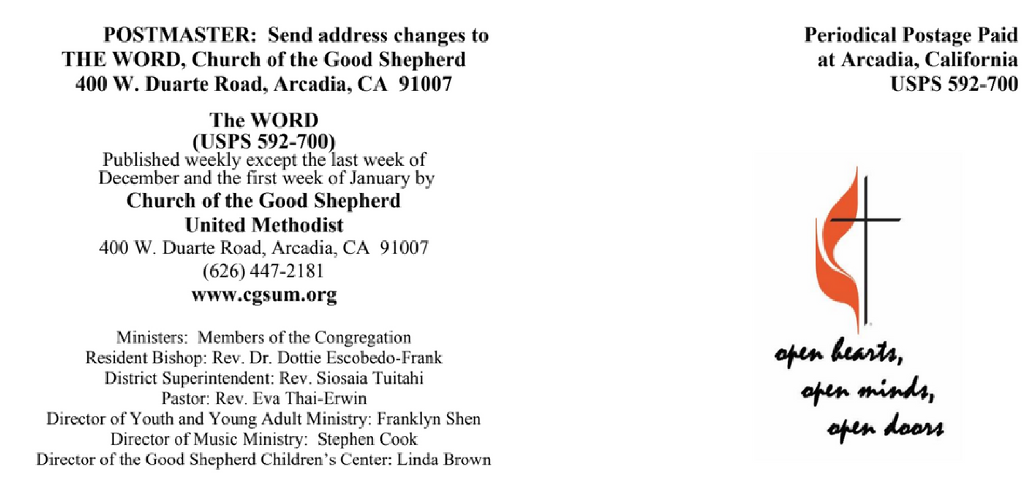
Prayer for the Week: (inspired by Matthew 5:21-37)
O God, send your Spirit upon us and light our path, that we may travel the road you have prepared for us. Having heard your scriptures proclaimed,
and your word revealed, enable our hearts and minds to more fully understand your goodness and your grace. -http://www.ministrymatters.com
Church of the Good Shepherd Mission Statement:
At Church of the Good Shepherd, god calls us to welcome all to a vibrant community on a continuing journey of Faith, Growth, Justice, and Service in the image of Christ.

